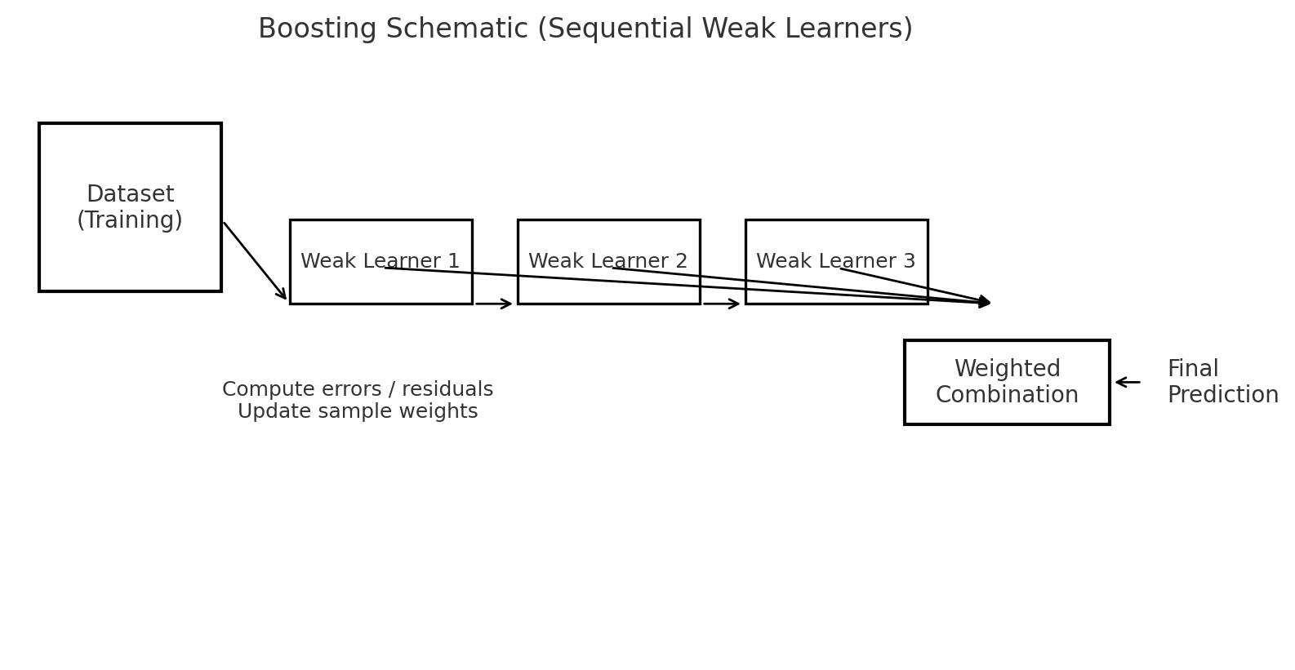

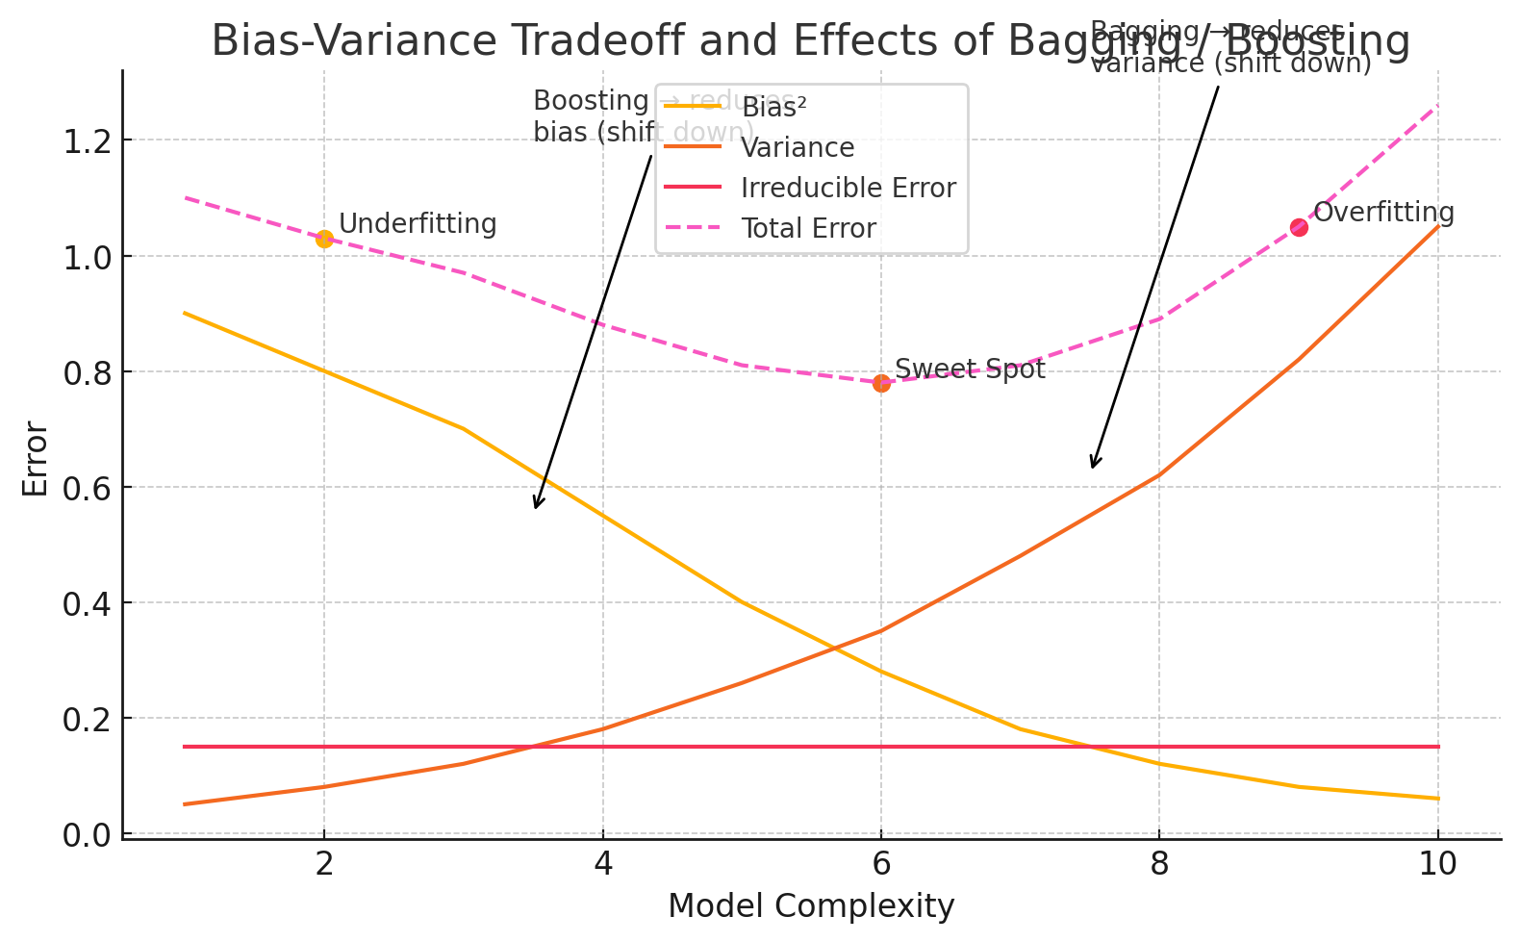

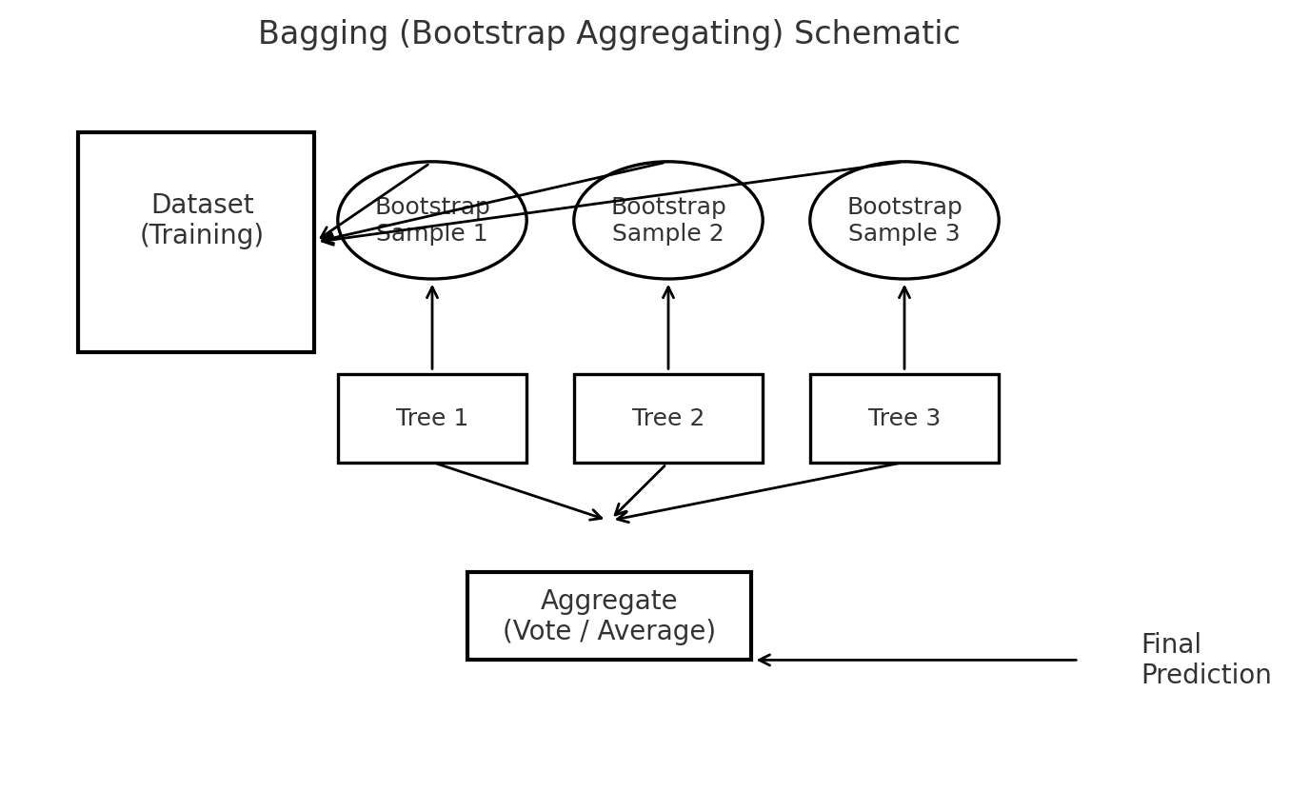

# Bagging (Bootstrap Aggregating)

Definition (short)
Bagging (Bootstrap Aggregating) is an ensemble method that builds multiple base learners (often the same model type) independently on different bootstrap samples of the training data, then aggregates their predictions (majority vote for classification, average for regression) to reduce variance and improve stability.

How it works (step-by-step)
- For t = 1..T (T = number of base learners):
  - Create a bootstrap sample by sampling n examples from the training set with replacement (size typically n, same as original).
  - Train a base learner hth_tht​ on this bootstrap sample.
- For a new input xxx:
  - Classification: predict by majority vote y^=mode(h1(x),…,hT(x))\hat{y} = \text{mode}(h_1(x), \dots, h_T(x))y^​=mode(h1​(x),…,hT​(x)).
  - Regression: predict by average y^=1T∑t=1Tht(x)\hat{y} = \frac{1}{T}\sum_{t=1}^T h_t(x)y^​=T1​∑t=1T​ht​(x).
Key intuition: averaging many independent high-variance but low-bias models reduces variance (law of large numbers).

Pseudocode
For t in 1..T:
S_t = sample_with_replacement(training_data, n)
h_t = train_base_learner(S_t)

To predict:
For input x, get predictions {h_t(x)}_{t=1..T}
Return majority_vote / average

Visual (see first diagram above)
You’ll see: dataset → bootstrap samples → train Tree1, Tree2, Tree3 → aggregate (vote/average) → final prediction.

When to use
- Best with high-variance base learners (e.g., unpruned decision trees).
- Works very well when you can parallelize training.
- Good when dataset is noisy; bagging stabilizes predictions.

Effects on bias & variance
- Main effect: reduces variance (since averaging reduces fluctuations from sample noise).
- Bias: roughly unchanged (bagging doesn’t make weak learners more complex); bias may slightly decrease if aggregation reduces some errors, but bagging’s primary purpose is variance reduction.

Pros / Cons
- Pros: Simple, parallelizable, improves stability, reduces overfitting of high-variance models.
- Cons: Doesn’t reduce bias much; models still have limited interpretability; uses more compute/memory.

Scikit-learn example
from sklearn.ensemble import BaggingClassifier
from sklearn.tree import DecisionTreeClassifier

bag = BaggingClassifier(base_estimator=DecisionTreeClassifier(),
n_estimators=100,
max_samples=1.0, # fraction or int
bootstrap=True,
n_jobs=-1,
random_state=42)
bag.fit(X_train, y_train)
y_pred = bag.predict(X_test)

# Random Forest (a specific Bagging variant)

Definition
Random Forest is a bagging ensemble of decision trees but with an important twist: at each node split, each tree considers only a random subset of features (not all features). This de-correlates trees and increases variance reduction.

Key differences from vanilla bagging
- Random feature selection at split time (max_features): prevents dominant strong predictors from being chosen in all trees, decreases correlation between trees ⇒ better variance reduction when aggregated.
- Use of fully grown or deep trees (usually) as base learners, which are high-variance; bagging + random features makes them robust.
- Out-Of-Bag (OOB) error: because each tree is trained on a bootstrap sample, ~36.8% of the original data is left out per tree and can be used to estimate model performance without a separate validation set.
- Feature importance: RF has built-in importance metrics (mean decrease impurity) and supports permutation importance.

Random Forest pseudocode (high-level)
For t in 1..T:
S_t = bootstrap_sample(data)
Build tree t:
At each split:
choose m features randomly from p
pick best split among those m
Return forest of trees {tree_t}
Prediction: majority or average over trees

Hyperparameters (important)
- n_estimators — number of trees (more = better up to compute limits)
- max_features — features sampled at each split (sqrt(p) for classification often)
- max_depth, min_samples_leaf — control tree complexity
- oob_score=True — to use out-of-bag validation

Scikit-learn example
from sklearn.ensemble import RandomForestClassifier

rf = RandomForestClassifier(n_estimators=200,
max_features='sqrt',
oob_score=True,
n_jobs=-1,
random_state=42)
rf.fit(X_train, y_train)
print("OOB score:", rf.oob_score_)

# Boosting

Definition (short)
Boosting is a family of sequential ensemble methods that build models iteratively: each new model focuses on correcting the errors (hard examples) made by the ensemble so far. The final prediction is a weighted sum (or vote) of weak learners. Boosting reduces bias (and can reduce variance) by combining many weak learners into a strong learner.

Two canonical algorithms (intuition + math)

1. AdaBoost (adaptive boosting) — classification
- Start with uniform sample weights wi=1/nw_i = 1/nwi​=1/n.
- For t = 1..T:
  - Train weak learner hth_tht​ on weighted data.
  - Compute weighted error: εt=∑iwi1[ht(xi)≠yi]∑iwi\varepsilon_t = \frac{\sum_i w_i \mathbf{1}[h_t(x_i) \neq y_i]}{\sum_i w_i}εt​=∑i​wi​∑i​wi​1[ht​(xi​)=yi​]​.
  - Compute weight of learner: αt=12ln⁡(1−εtεt)\alpha_t = \frac{1}{2}\ln\left(\frac{1-\varepsilon_t}{\varepsilon_t}\right)αt​=21​ln(εt​1−εt​​).
  - Update sample weights: wi←wiexp⁡(−αtyiht(xi))w_i \leftarrow w_i \exp(-\alpha_t y_i h_t(x_i))wi​←wi​exp(−αt​yi​ht​(xi​)) (then normalize). Misclassified samples get higher weights.
- Final classifier: sign(∑tαtht(x))\left(\sum_t \alpha_t h_t(x)\right)(∑t​αt​ht​(x)).

2. Gradient Boosting (regression/classification; more general)
- View boosting as stage-wise additive modeling that minimizes a differentiable loss L(y,F(x))L(y, F(x))L(y,F(x)).
- Initialize F0(x)F_0(x)F0​(x) (e.g., constant).
- For m = 1..M:
  - Compute pseudo-residuals ri(m)=−∂L(yi,F(xi))∂F(xi)∣F=Fm−1r_{i}^{(m)} = -\left.\frac{\partial L(y_i, F(x_i))}{\partial F(x_i)}\right|_{F = F_{m-1}}ri(m)​=−∂F(xi​)∂L(yi​,F(xi​))​​F=Fm−1​​.
  - Fit weak learner hm(x)h_m(x)hm​(x) to the residuals ri(m)r_i^{(m)}ri(m)​.
  - Compute multiplier γm\gamma_mγm​ (line search) and update Fm(x)=Fm−1(x)+νγmhm(x)F_m(x) = F_{m-1}(x) + \nu \gamma_m h_m(x)Fm​(x)=Fm−1​(x)+νγm​hm​(x) where ν\nuν is the learning rate (0 < ν\nuν ≤ 1).
- Examples: GradientBoosting, XGBoost, LightGBM, CatBoost.

Intuition
- AdaBoost: reweights examples so next learner focuses on mistakes.
- Gradient Boosting: fits weak learners to the residuals (negative gradient of loss), performing functional gradient descent.

Pseudocode (Gradient Boosting simplified)
F0(x) = argmin_gamma sum_i L(y_i, gamma)
for m=1..M:
r_im = -[d/dF L(y_i, F(x_i))]_{F=F_{m-1}}
h_m = fit_regressor(X, r_im)
gamma_m = argmin_gamma sum_i L(y_i, F_{m-1}(x_i) + gamma*h_m(x_i))
F_m = F_{m-1} + learning_rate * gamma_m * h_m
predict: y_hat = F_M(x)

How boosting changes bias & variance
- Primary effect: reduces bias — boosting sequentially corrects residual errors, allowing the ensemble to fit complex patterns that weak learners alone couldn’t model.
- Variance: boosting can reduce variance, but because learners are added sequentially and can overfit, boosting implementations include regularization (learning rate, subsampling, tree depth) to control variance.
- Practical: boosting often outperforms bagging in predictive power (esp. on tabular data), but requires careful hyperparameter tuning (e.g., small learning_rate, more trees).

Popular Boosting Implementations and Hyperparameters
- AdaBoostClassifier (sklearn): n_estimators, learning_rate.
- GradientBoostingClassifier / Regressor (sklearn): n_estimators, learning_rate, max_depth, subsample.
- XGBoost / LightGBM / CatBoost: additional regularization params (lambda, alpha), colsample_bytree, subsample, and efficient hist-based algorithms.

Scikit-learn snippet (AdaBoost & GradientBoosting)
from sklearn.ensemble import AdaBoostClassifier, GradientBoostingClassifier

ada = AdaBoostClassifier(n_estimators=100, learning_rate=1.0, random_state=42)
ada.fit(X_train, y_train)

gb = GradientBoostingClassifier(n_estimators=200, learning_rate=0.1, max_depth=3, subsample=0.8, random_state=42)
gb.fit(X_train, y_train)
For production-grade boosting: use XGBoost / LightGBM:
import xgboost as xgb
model = xgb.XGBClassifier(n_estimators=500, learning_rate=0.05, max_depth=4, subsample=0.8, colsample_bytree=0.8)
model.fit(X_train, y_train, early_stopping_rounds=50, eval_set=[(X_val, y_val)])

# Bagging vs Boosting — Key Differences (side-by-side)
Aspect | Bagging | Boosting
Training order | Parallel (independent models) | Sequential (ordered)
Focus | Reduce variance by averaging | Reduce bias (and often variance) by focusing on mistakes
Data sampling | Bootstrap sampling (with replacement) | Often uses reweighting or residuals; not necessarily bootstrap
Base learners | Typically strong, high-variance learners (e.g., deep trees) | Typically weak learners (shallow trees)
Aggregation | Simple averaging or voting | Weighted sum / staged additive model
Parallelizable? | Yes (fully parallel) | No (sequential), though some optimizations exist
Tends to | Improve stability, avoid overfitting of single high-variance models | Increase predictive power, can overfit if not regularized

# Random Forest vs Generic Bagging (again: quick comparison)
- Random Forest = Bagging + random feature selection at each split (decorrelates trees).
- Generic Bagging could use any model and usually uses entire feature set for splits.
- Random Forest typically uses full-size bootstrap samples and unpruned deep trees; bagging could also use shallower learners.
- Random Forest provides OOB error and fast, robust feature importance measures.
- In practice, Random Forest is the standard bagged tree algorithm and often outperforms a vanilla bagged tree ensemble because of reduced correlation among trees.

# Diagrams (you should see these above)
- Bagging schematic — shows bootstrapping, parallel trees, aggregation.
- Boosting schematic — shows sequential weak learners, error/residual update, weighted combination.
- Bias–Variance curve — shows Bias² (decreasing with complexity), Variance (increasing), Irreducible error, Total error; indicates that bagging mainly shifts the Variance curve down, while boosting shifts the Bias curve down (but both affect total error differently).
(If you want, I can export these diagrams into a single PDF/PNG for quick printing. Tell me and I’ll generate it now.)

# Mathematical Intuition (compact)

Bagging (variance reduction)
If each model hth_tht​ has expected error with variance σ2\sigma^2σ2 and pairwise covariance ρσ2\rho\sigma^2ρσ2, then the variance of the averaged predictor is:
Var(1T∑t=1Tht)=1T2(Tσ2+T(T−1)ρσ2)=σ2T(1−ρ)+ρσ2\text{Var}\left(\frac{1}{T}\sum_{t=1}^T h_t\right) = \frac{1}{T^2}\left(T\sigma^2 + T(T-1)\rho\sigma^2\right) = \frac{\sigma^2}{T} (1 - \rho) + \rho\sigma^2Var(T1​t=1∑T​ht​)=T21​(Tσ2+T(T−1)ρσ2)=Tσ2​(1−ρ)+ρσ2
- If ρ\rhoρ is small (low correlation between learners), variance decreases approximately by 1/T1/T1/T.
- Random feature sampling in Random Forest helps reduce ρ\rhoρ, improving variance reduction.

AdaBoost (exponential loss view)
AdaBoost minimizes the exponential loss:
∑iexp⁡(−yiF(xi)),F(x)=∑tαtht(x)\sum_{i} \exp(-y_i F(x_i)),\qquad F(x)=\sum_{t}\alpha_t h_t(x)i∑​exp(−yi​F(xi​)),F(x)=t∑​αt​ht​(x)
Updating sample weights emphasizes misclassified points exponentially; the algorithm can be shown to minimize training error quickly and often reduces bias.

Gradient Boosting (functional gradient)
Boosting is functional gradient descent on loss LLL, fitting weak learners to negative gradients (pseudo-residuals).

# Practical Tuning Tips & Tradeoffs

Bagging / Random Forest
- Increase n_estimators until OOB/validation error stabilizes.
- Set max_features to sqrt(p) for classification (or p/3 for regression) as starting point.
- Use max_depth / min_samples_leaf to limit tree complexity if overfitting is observed.
- Use oob_score=True for quick validation.

Boosting (Gradient / XGBoost / LightGBM)
- Key knobs: learning_rate (smaller → need more trees but generalizes better), n_estimators, max_depth (shallow trees are often better), subsample (stochastic gradient boosting), colsample_bytree (feature subsample).
- Use early stopping on a validation set to avoid overfitting.
- For noisy data, reduce learning_rate and increase subsample regularization.

# Practical Example Workflow (toy experiment idea)
- Train a deep decision tree (no pruning) → expect low bias, high variance (overfit).
- Train a RandomForest → variance reduced, better test performance.
- Train a GradientBoosting model with shallow trees and low learning rate → bias reduces and final generalization often better than either tree or RF (with tuned params).
If you want I can run a small experiment now (train a decision tree, RF, AdaBoost/GBM on synthetic data and show train/test errors and curves). Say the word and I’ll run it.

# Interview Questions & Short Answers
- Q: Why bagging reduces variance?
A: Because averaging independent predictors reduces variance (errors cancel out), and bootstrapping creates diverse models.
- Q: Why does Random Forest use random features?
A: To decorrelate trees — if one strong feature dominates splits, all trees become similar; random feature selection forces diversity and improves averaging benefit.
- Q: How does boosting reduce bias?
A: Boosting fits subsequent models to the errors/residuals of the ensemble, iteratively improving fit to complex patterns that simple weak learners miss.
- Q: When would you use bagging vs boosting?
A: Use bagging/random forest when base learners are high-variance (trees) and you want stability; use boosting when you need highest predictive accuracy and can tune carefully (and accept longer training/sequential nature).
- Q: Does boosting overfit?
A: It can, especially with large trees and high learning rates. Regularization (small learning rate, early stopping, shallow trees) mitigates overfitting.
- Q: What is OOB error?
A: Out-Of-Bag error estimates performance by using samples not included in a tree’s bootstrap to evaluate that tree; aggregated across trees gives an unbiased estimate.
- Q: Which is faster to train, bagging or boosting?
A: Bagging can be parallelized and thus faster on parallel hardware; boosting is inherently sequential and typically slower.

# Quick Cheat-Sheet (one paragraph)
- Bagging = bootstrap samples → parallel training → aggregate; reduces variance.
- Random Forest = bagging + random feature subset at splits → decorrelates trees + OOB.
- Boosting = sequential weak learners focusing on prior errors → reduces bias (and sometimes variance), e.g., AdaBoost, GradientBoosting (XGBoost, LightGBM).
- Tune bagging with n_estimators, max_features; tune boosting with learning_rate, n_estimators, max_depth, subsample.
- Pick bagging/RF for high-variance base learners; pick boosting for top predictive performance when careful tuning and regularization are possible.

